District Rocky Mountain held its winter meeting at the Sandlot Brewery in Denver on February 8th. John Legnard, of the Sandlot Brewery spoke on the subject of “Brewing at a Baseball Stadium Brewery.” This was the first meeting using the new, automated pay system online. While there are still a few kinks to work out, it seems that the system works well and check in ran smoother than ever before. This is that much more impressive because there were a whopping 158 people in attendance at the meeting!

The meeting started off with a social hour that took place concurrently at the bar and behind the glass of the brewery. Attendees had their choice of Helles, Weizen, and Doublebock from the bar, or an assortment of beers brought by other brewers downstairs. Naturally, it was a crowded, jovial atmosphere downstairs, as everyone checked out the equipment, mingled, and tasted some fun beers. With permission from the friendly security guard, participants were allowed to walk out to the bleacher platform and see the field covered with snow.

After the social hour, a traditional ballpark dinner of hot dogs and nachos was served. Miller Coors generously contributed funds to help MBAA cover the cost of dinner. After everyone was done eating, the group congregated on one end of the bar for the business meeting and technical presentation.

District President Gary Dick kicked off the meeting by thanking the Sandlot brewery for hosting the meeting and Miller Coors for helping to subsidize it. Gary next offered Matt Thrall of Avery Brewing our collective congratulations and thanks for officially accepting the position of district Secretary. Jeff Biegert of New Belgium, who is the new scholarship chairman, next gave a description of the scholarship funds that our district offers, and Jonathan Kemp of A-B gave a short description of his trip to the MBAA national convention, which was funded with scholarship funds. It was announced that Rob Molin of Grand Teton Brewing won a copy of “The Practical Brewer” for his participation in the membership survey. Finally Mike Sutton, MBAA National President who was in visiting our fair state, got up to recognize our district’s success and plugged the World Brewing Congress this summer.

Technical Chairman Finn Knudsen of Knudsen Beverage Consulting then “talked about technical stuff because that’s what technical chairs do.” (His words.) He plugged the technical session being planned for June and introduced the guest speaker, John Legnard. John graduated from CSU and started his career as a Quality Control Technician at Coors. A short time later he helped start HC Berger Brewing Co, and has also helped with the first brews at several breweries including Great Divide and Left Hand. John has been at the Sandlot Brewery since it opened in 1995.

John’s presentation covered the unique challenges of brewing at the Sandlot: challenges from working within a baseball stadium, in a space co-owned by a large food vendor company, and as a small subsidiary of a very large brewery, Miller-Coors. John introduced the staff of the Sandlot, some of whom have been with the brewery since its inception, a testament to the strength of their team.

In 1995, the Sandlot became the first baseball stadium brewery in the country. From 2001-2005, the brewery began to get more experimental, brewing more than the conventional styles that the public was demanding. Blue Moon was among these “experiments.” They began to see lots of success at GABF as a result of their experimentation. In 2006, Coors realized the marketing potential of the Sandlot, and renamed it “Blue Moon Brewery at the Sandlot.” Since 2008, the brewery has been at 100% capacity year round.

The challenges that the brewers at the Sandlot face include the fact that the brewpub is actually only open 81 days per year. The brewers are limited to brewing styles that appeal to the baseball fans, not necessarily what appeal to craft beer drinkers.

There is no loading dock at the brewery; deliveries must come through the loading dock in center field and be brought halfway around the stadium. And this is very limited during game days. Imagine how difficult that is for spent grain storage and removal! The work space for the brewery (behind a glass wall) is owned by Miller-Coors, though the restaurant is owned by Aramark. Because of the strict liquor licensing, the brewers need to be careful about where beer is consumed or carried.

When VIPs are visiting the stadium, security at their work place exceeds anything most brewers normally have to work around. The security is necessary, though, because baseball stadiums are particularly prone to drunk trespassers wanting to break onto the field and thus into their workspace. Thus employees run the risk routinely of being suspect as trespassers during off-hours in their own work space.

Next John discussed the challenges of working for Miller-Coors that separate them from most other tiny breweries. Despite their size, because they are part of a large company, they have rigorous safety inspections with 545 checklist items. They also have a five page checklist of items required to bring a beer to market.

The brewery was originally started as part of the R&D department of the company. Because it wasn’t bringing in much money, it was then moved to the sales/marketing division because it was seen as a marketing asset. During that time, they’ve had 17 bosses in as many years with lots of turnover within the whole marketing department, and had to make “creative” products at the request of marketing such as Peanut Butter Ale. As a part of marketing, they have a limited budget for high level equipment, and are forced to be creative with their process (for example, mashing in based on timing the water flow, in the absence of a flow meter).

Now that the company has started focusing more on craft beer (with the addition of Tenth and Blake), the Sandlot is getting more attention and given more leeway to stretch their brewing muscles. John concluded by stressing the incredible benefit of working for Miller-Coors, which is that they have a wealth of experts, many with PhDs, in all subject available for consultation. They are happy to be part of such a high quality team.

After the presentation, John was thanked again for speaking, as well as for hosting us, with an engraved mug from the Rocky Mountain District. And as is customary, the evening concluded with a very lively raffle of prizes supplied by many of the members. The next meeting of District Rocky Mountain will be held in Fort Collins on April 11th, 2012, at the Anheuser-Busch Brewery.

Tamar Banner
Publicity Chair
Master Brewers Association of the Americas - District Rocky Mountain
February 28, 2012
Attached photos:

Photo 1: The crowd mingling in the basement of the Sandlot Brewery.
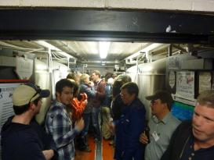
Photo 2: Gary Dick and Jonathan Kemp at the newly improved check-in desk.
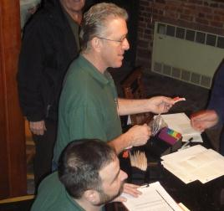
Photo 3: The Sandlot logo and the empty ballpark in the snow.
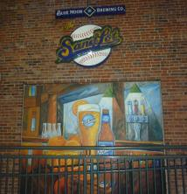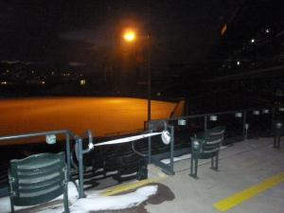
Photo 4: The team from Avery Brewery: Ian, Jesse, Mel, Rob, and Kelly Tretter from New Belgium.
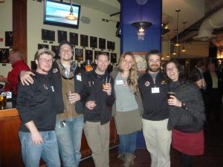
Photo 5: Finn Knudsen presenting John Legnard with his mug.
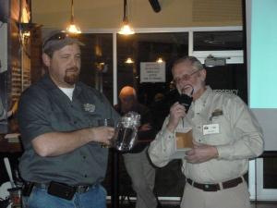
Photo 6: Teri Fahrendorf and Tammy Johnson, finding floor seating before the presentation.
